Odoo Field Service – Workers

Contents

What is a Worker? 1

Categories 1

Working Schedule 1

Skills 2

Territories 2

Linked Locations 3

Agreements 3

Creating a Worker 3

Via Field Service App (Recommended) 3

Via Contacts App (Only if Contact is already Created) 4

# What is a Worker?

A Field Service Worker is any individual or company that will have a Field Service Order assigned to them where they will perform a measurable amount of work. A Worker can be an Employee or Sub-Contractor (Vendor).

Field Service Workers in Odoo is an extension of the Partner module (aka Contacts). This means that every worker created in Odoo will have a linked partner record. Because they are linked, all partner record fields are accessible via the worker record.

To access Field Service Workers, go to **Master Data** then **Workers**:

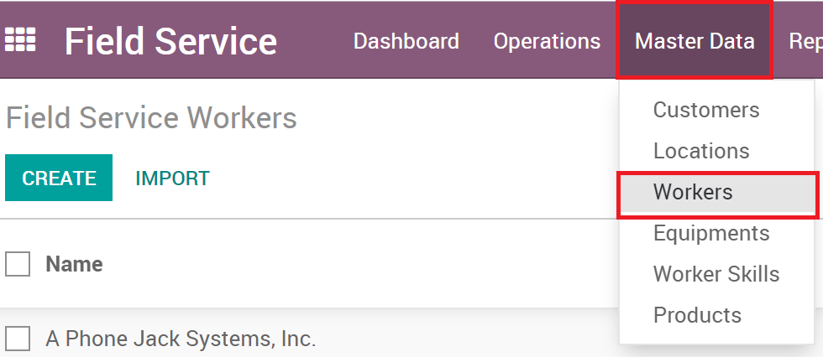

# Categories

Worker Categories can be assigned to workers to provide a way to add searchability and organization to the worker records. Multiple Categories can be assigned to a worker. Categories are managed by users with manager permissions.

# Working Schedule

Odoo can have detailed schedules to be used on many different types of records and are called working schedules. A working schedule contains detailed line items for the hours and times for the schedule and can be as detailed as needed. Working Schedules are managed by users with user permissions.

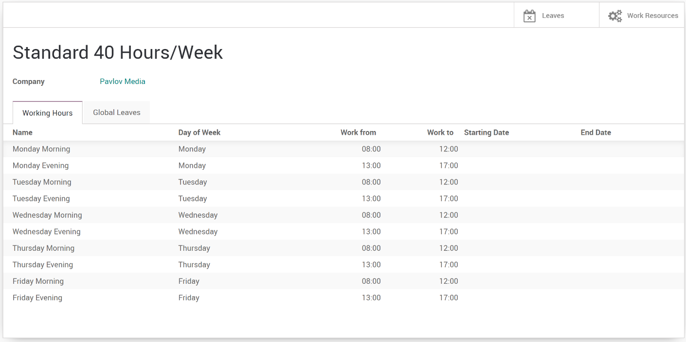

# Skills

Workers can have skills and skill levels assigned to them. These describe the experience the worker has and can be used when assigning work to them. When you add a skill to a worker, you will also set the level of that skill for the worker.

Skill Levels:

* No Stars - Beginner
* 1 Star - Intermediate
* 2 Stars - Senior
* 3 Stars - Expert

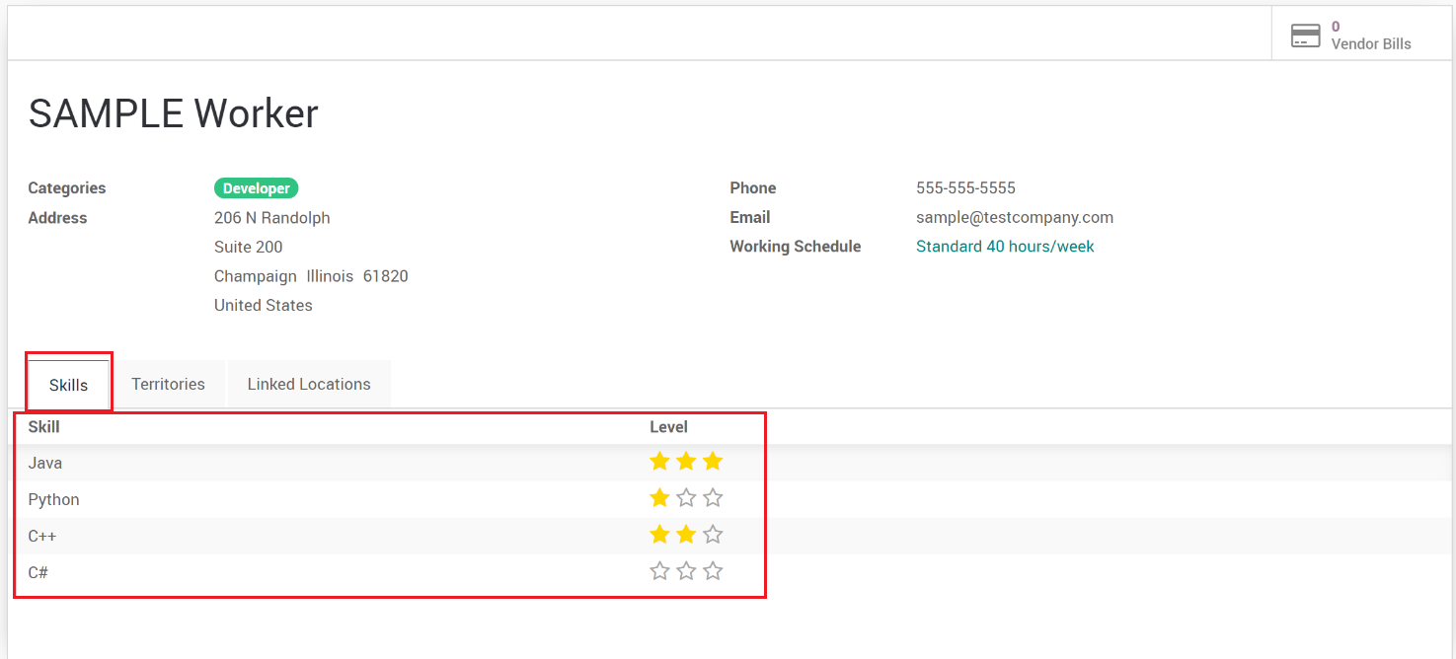

# Territories

Territories allow for a way to group workers into specific areas. Territories are also assigned to customers and locations therefore matching workers to customer or location is done so in an easy way. A worker can belong to multiple territories. Territories are managed by users with manager permissions.

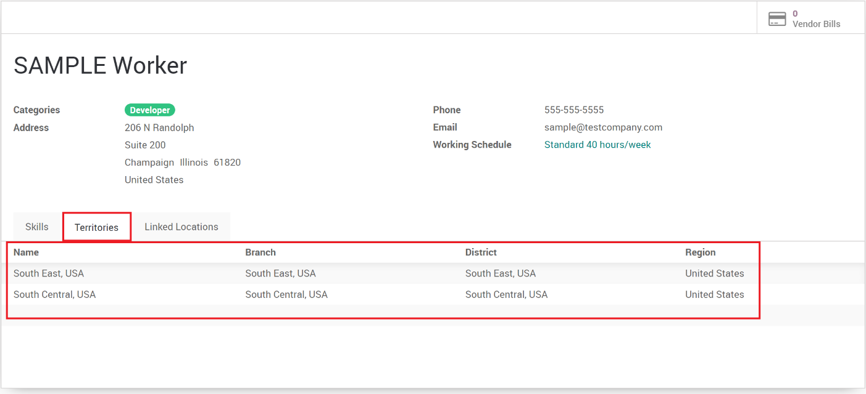

# Linked Locations

Field Service Locations can be linked to workers, providing a way to assign a worker to a location. This is used when finding a tech for a field service order. A worker can be linked to multiple locations.

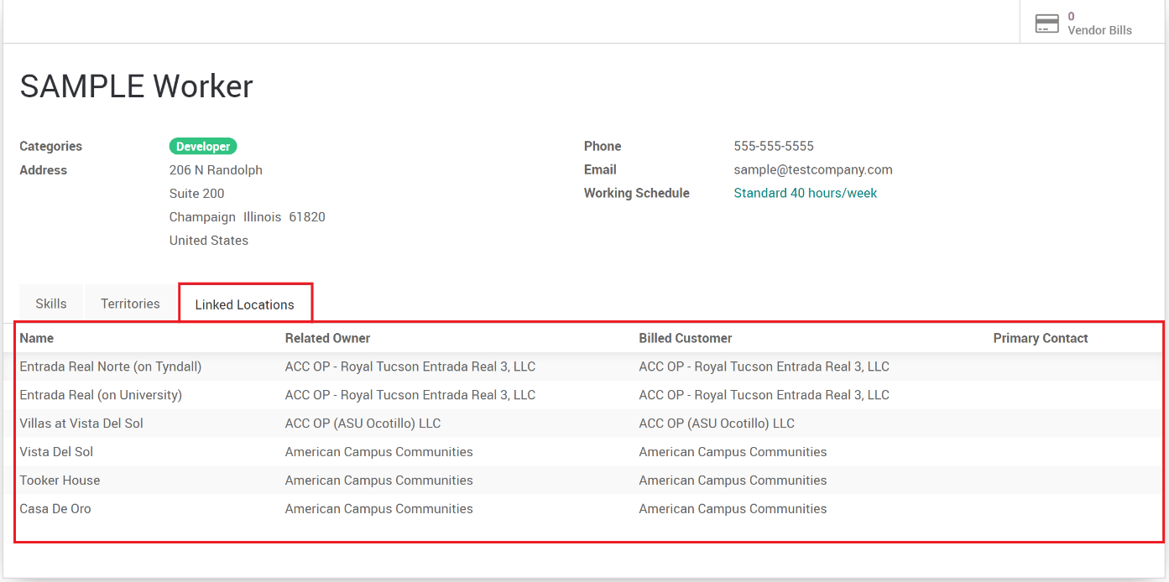

# Agreements

Sometimes workers will have agreements or contracts with the company, especially sub-contractors. Agreements for the workers are accessed via the smart button.

**This item is being developed so a screenshot to be provided once developed**

# Creating a Worker

Workers can be created in several ways, but it’s recommended to create a worker from the field service app.

## Via Field Service App (Recommended)

Best practice is to create new workers in the Field Service App.

1. Go to **Master Data**, then **Workers**.
2. Click the **Create** button.
3. Fill in the proper information.

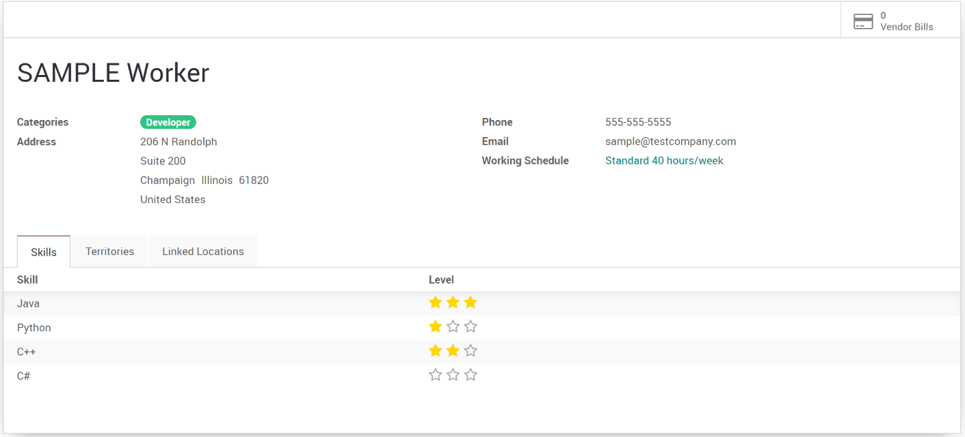

Fields List:

* 1. **Name**: Name of the worker which could be a company or individual.
  2. **Categories**: Categories assigned to the worker.
  3. **Address**: Full Address of the worker.
  4. **Phone**: Primary Phone of the worker.
  5. **Email**: Primary Email of the worker.
  6. **Working Schedule**: The normal business hours/working schedule of the worker.
  7. **Skills**: List of Skills and Skill Levels the worker has experience with.
  8. **Territories**: List of Territories the worker is linked to.
  9. **Linked Locations**: List of locations the worker is linked to.
  10. **Vendor Bills (Smart Button)**: Shows Vendor Bills linked to the worker.
  11. **Agreements (Smart Button)**: Shows Agreements linked to the worker.

## Via Contacts App (Only if Contact is already Created)

If a worker already has a contact record, then you can convert the contact to a worker record. For any new workers who don’t have a contact record, it’s best practice to create the worker within the field service app.

To convert a contact to a worker:

1. Open the **Contact.**
2. Go to **Actions**, then select **Convert to FSM Record.**

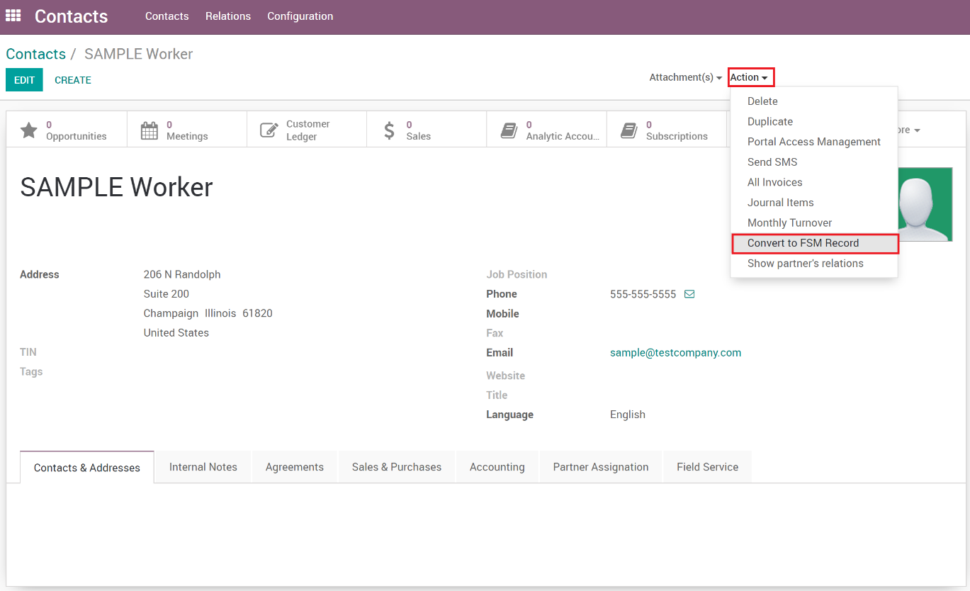

1. A wizard will open, select **Worker** in the drop down then click the **Convert** button.

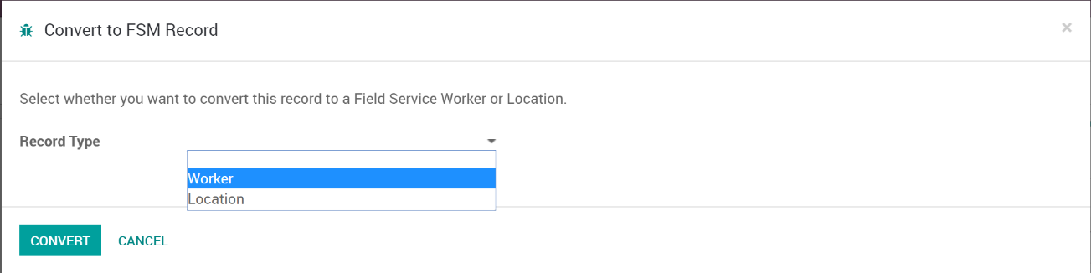

1. Once completed, you can then go into the Field Service App and open the worker record.